Simple list view



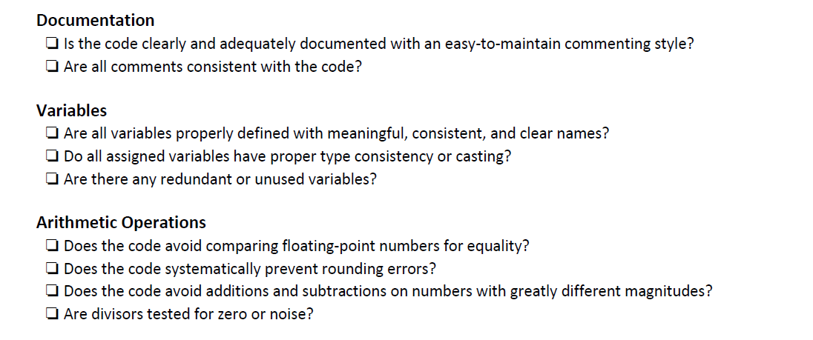



Hash tables

